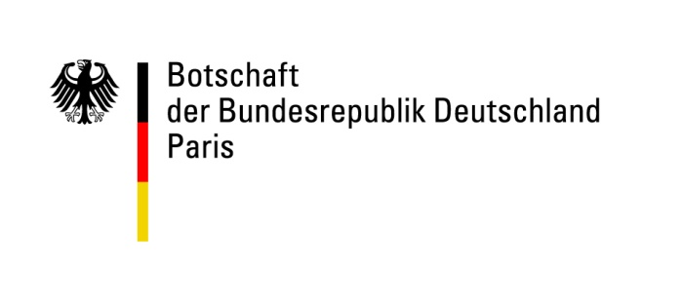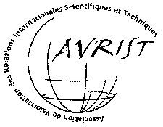

Science diplomacy in action
Governance for international science co-operation:
the example of Health research
- under the patronage of the Académie de médecine, Paris -

Organisation: | AVRIST (Association de valorisation des relations internationales scientifiques et technologiques) together with the Embassies of Great Britain and Germany and in collaboration with the Embassy of the United States
Date: | February 11th and 12th, 2013
Site: | Paris, Institut Pasteur, 28 rue du Docteur Roux, Paris 15ème, Auditorium du BIME
Objective: | Science and technology can play a crucial role in tackling global challenges. However, although scientists increasingly work in international networks and multilateral contexts, there are still considerable obstacles to their working effectively together.  Improvements to transnational and international governance are therefore needed with the main protagonists and stakeholders being national governments, transnational organizations, scientific communities and NGO’s. Science diplomacy is therefore central.  The OECD project “International co-operation in science, technology and innovation: meeting global challenges through better governance” (2012) analysed a range of governance mechanisms used for international cooperation to address global challenges.  This analysis identified a number of weaknesses such as:  - difficulties reaching international agreement on common priorities  - insufficient modalities of funding,  - obstacles to the transfer of science, technology and innovation into practice,  - insufficient participation of relevant actors in society  - the lack of integration of countries with weak scientific infrastructure.  - problems of intellectual property rights for applications of new technologies.  The objective of the colloquium on 11 and 12 February is to discuss possible options for the further development of governance models, which can contribute to overcoming some of these weaknesses. In order to limit the breadth of the issue, the colloquium will take the field of health science as an example.
Program – draft

February 11th
9.30 – 10 am | Opening  - Alice Dautry, Directrice générale Institut Pasteur  - Sir Peter Ricketts, British Ambassador to France  - Susanne Wasum-Rainer, German Ambassador to France  - Hélène Duchêne, Directrice des politiques de mobilité et d’attractivité, Ministère des affaires étrangères  - Jean-Luc Clément, Conseiller recherche à la direction des relations européennes et internationales et de la coopération, Ministère de l’Enseignement supérieur et de la recherche
10 – 10.15 am | Keynote speech: Science - always keeping the door open  Anne Glover, Chief Scientific Adviser European Commission
10.15 – 10.45 am | -- Coffee break --
10.45 – 11.45 am | First part: Presentation of the Current State of Affairs – moderator: Candy Green  - Addressing global challenges through better governance - International cooperation in science, technology and innovation  Andreas Stamm, German Development Institute, Corrdinating scientist of the OECD-study (confirmed)  - Science and Societal Challenges: Moving Ahead  Ken Guy, Head of OECD-STP (confirmed)
11.45 – 12.45 pm | Second part: Individual stakeholders in global health research (industry, research institutions, foundations), session I – moderator: Matthew Houlihan  - Roger Genet, Directeur général de la recherche et de l’innovation, Ministère de l’Enseignement supérieur et de la recherche (confirmed)  - The French National Academy of Medicine and international cooperation in health research  Raymond Ardaillou, Académie de médecine (confirmed)  - Global Health at Imperial College  Dermot Kelleher, Imperial College London (confirmed)
12.45 – 14.15 pm | -- Lunch buffet --
14.15 – 16.15 pm | Second part: Individual stakeholders in global health research (industry, research institutions, foundations), session II – moderator: Matthew Houlihan  - André Syrota, Président AVIESAN (confirmed)  - Creating Value through Biomedical Innovation Ecosystems in Heath Care  Isabelle Thizon de Gaulle, Sanofi  - Claude Bertrand, Président ARIIS, Alliance pour la Recherche et l'Innovation des Industries de Santé (confirmed)  - Benoît Miribel, Fondation Mérieux (confirmed)  - François Sigaux, Cancéropôle Ile de France (confirmed)
16.15 – 16.45 pm | -- Coffee break --
16.45 – 18.15 pm | Third part: Multilateral actors in global health research, session I – moderator: Annick Suzor-Weiner  - The fight against infectious diseases: an example of International, European and French policies  Patrice Debré, European and Developing Countries Clinical Trials Partnership and Hôpital Pitié Salpêtrière (confirmed)  - Responsibility of Academia for Global Health: The World Health Summit and the M8 Alliance  Detlev Ganten/Jean-François Girard, President World Health Summit/President of University Paris Sorbonne Cité (confirmed)  - Academic Delivery of Global Health Solutions  Dermot Kelleher, Imperial College London (confirmed)
19 pm | Reception at the Hôtel de Beauharnais, residence of the German ambassador to France (78 rue de Lille, 75007 Paris, metro line 12 Assemblée Nationale)
February 12th
9 – 10.30 am | Third part: Multilateral actors in global health research, session II – moderator: Jean-Claude Arditti  - Governance issues in the context of the recommendations of WHO`s  Consultative Expert Working Group on Research and Development (CEWG)  Albrecht Jahn, member of CEWG, WHO (confirmed)  - Zafar Mirza, WHO (confirmed)  - Health and Wellbeing in the Changing Urban Environment: the ICSU Initiative  Gérard Salem and Carthage Smith, ICSU Committee for health and well-being (confirmed)  - Boosting Drug Development through Public-Private Partnerships – The IMI Model  Hugh Laverty, Innovative Medecines Initiative (confirmed)
10.15 – 10.45 am | -- Coffee break --
10.45 am – 13 pm | Fourth part: New governance models in global Science and Innovation endeavours - Open governance, a vision for the future? – moderator: Klaus Matthes  - Earth Cube: a community-based cyberinfrastructure for knowledge management across the geosciences  Carmen Huber, NSF Earth Cube Program (confirmed)  - Transformation needs for international governance, conclusions from experiences in environment policy  Philipp Pattberg, University of Amsterdam (confirmed)  - Constitutive Moments of Governing Expertise: The case of the Intergovernmental Panel on Climate Change  Silke Beck, Environmental Research Center Leipzig (confirmed)  - Open Collaboration in Policy Modelling: a Contribution to Open Government  Maria Wimmer, University of Koblenz-Landau, Koblenz (confirmed)  - Keith Smith, Imperial College London (confirmed)  - Options for future governance in research and innovation  Luc Soete, Rector Maastricht University (confirmed)
13 - 14 pm | -- Lunch buffet --

http://www.oecd-ilibrary.org/science-and-technology/meeting-global-challenges-through-better-governance_9789264178700-en

